Instructions for

Microsoft Cloud and Enterprise Symbol Set Version 2.3

# What

This is the official symbol set for both the Azure User Experience (UX) and the Microsoft Content Services & International (CSI) group. The UX group creates the look and feel for [www.microsoft.com/azure](http://www.microsoft.com/azure) and the Azure Management Portals. The CSI group maintains most of the official Azure technical documentation on MSDN and the azure.microsoft.com web site. Many symbols are used in the [Azure Infographics](http://www.windowsazure.com/en-us/documentation/infographics/) and [Microsoft Architecture Blueprints](http://msdn.microsoft.com/dn630664).

The symbol set includes not only those for Azure, but also on-premises products like Windows Server and SQL Server.

# Why

Using these symbols to describe systems built with Azure and other Microsoft products helps establish a consistent visual language. This speeds the understanding of system scenarios and architectures and anchors discussions among Microsoft employees, customers, and other 3rd parties.

# Use where and when

Use the symbols in architectural diagrams, training decks or your own documentation as appropriate. Also download the [New Office Visio Stencil](http://www.microsoft.com/en-us/download/details.aspx?id=35772) which contains over 300 useful symbols and icons. When there is a conflict between the sets, use the symbols in the Cloud and Enterprise set over those in other sets.

# Feedback

Feel free to provide feedback using the short survey at <http://aka.ms/CnESymbolsSurvey> .

Email [CnESymbols@microsoft.com](mailto:CnESymbols@microsoft.com) for feedback that falls outside the survey. We like positive feedback too so we know what’s useful and don’t remove it in future revisions. Feel free to send examples of how you are using the symbol set and suggestions for improvements.

# Zip files

There are two types of files in this package.

**Visio Stencil (.vss)** - This file contains all the symbols in two forms. One version is opaque, meaning it has a white background. The other version is not and you can see the background through some parts of the symbol.

See additional instructions later in this document for using the Visio version of these symbols.

**PNG .ZIP file** – The same set of symbols, but in transparent PNG form.

**PowerPoint file (.ppt)** – We no longer ship a PowerPoint file because it is very easy to get the symbols into PowerPoint yourself and likely faster to search for the PNGs in a folder than through PowerPoint. You can also drag and drop symbols directly from Visio or the Visio stencil with the same effect.

# **Color**

Though not a set standard, these symbols try to use color to draw a distinction between different product sets. Consider using these same colors for consistency. This will help you separate when the same or similar features are run in different places. For example, virtual machines can be generic, run in Microsoft Azure, on Windows Azure Pack or on Windows Server on-premises.



**Usage in PowerPoint**

Open up a folder containing all the PNG files.

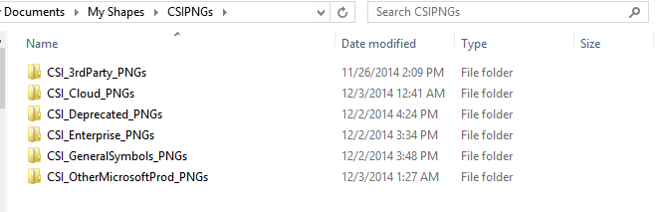

Then type in what you want to find. Once you find the right symbol, drag and drop it into PowerPoint.

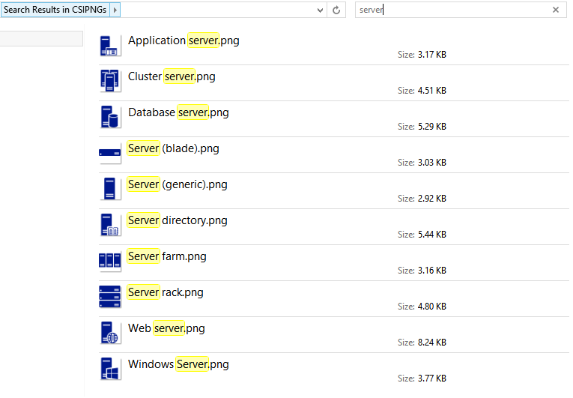

Use the FORMAT menu and the COLOR option to change the color of the symbols after they are in PowerPoint as shown in the picture below. 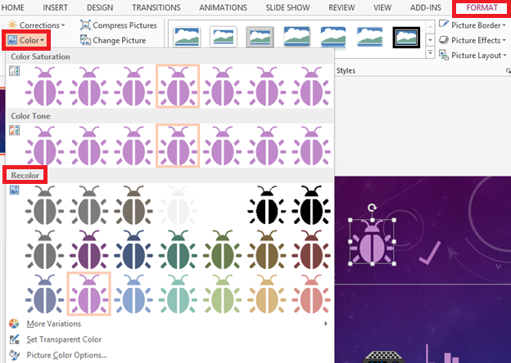

# **Instructions for Visio**

We suggest you set up Visio to use the Zoom options with the mouse wheel. It makes moving around large diagrams MUCH faster. Turn it on using the options below. Select any object on the diagram, use the mouse wheel, and you’ll see.



**Visio**

We suggest you set up Visio to use the Zoom options with the mouse wheel. It makes moving around diagrams MUCH faster. Turn it on using the options below. Select any object on the diagram, use the mouse wheel, and you’ll see.

The symbols are in Visio 2010 format so older versions of Visio can use them. Here’s a few tips. Video training is available at <http://aka.ms/CnESymbolsVideo>.

* **Open a new “blank” Visio diagram**. Opening a diagram of a specific type such as “flowchart” may change and recolor the icons when you drag them onto the page due to the use of Themes.
* **Symbol text.**  Once you drag and drop a symbol on to the page, it’s very easy to erase or change text. The symbol will remain highlighted after being dropped. If you click elsewhere, it will be un-highlighted, so just click on the symbols again ONCE to highlight it. Once the symbol is highlighted, the following actions will work.
* **To change** the text just start typing after dropping the symbol on the Visio page. The symbol will still be highlighted when you drop it, so any keystrokes erase the previous text and add your new text.
* **To erase all the text** just press a key to start adding text and then immediate press the “backspace” key to erase that one letter.
* **To modify the text,** press F2 and one of the arrow keys.
* **Fill and outline -** You can color the symbols that are not “stackable” very easily. You highlight them and then use the fill button to change the color. The Stackable symbols will not do this as easily as they are multi layered. If you fill them, you will get a large blob unless you click around to find the other layers in the symbol and fill those individually. The same holds true for change the outline. The Symbols do not come with outlines.



## Other Applications

You can also drag and drop these symbols from Visio into other applications. Sometimes they will stay in vector form allowing you to make the symbols larger with no loss of quality. Other times they are converted into bitmaps. If the edges of a symbol lose their smoothness when you make them large, it’s likely that it has been converted to a bitmap format.

Visio can also save symbols into SVG (Scalable vector graphics) format. SVG can be imported into other applications such as Adobe Illustrator or InkScape. If you desire to have the set in another format, you are welcome to email [AzureSymbols@microsoft.com](mailto:AzureSymbols@microsoft.com) to see if that is available.

## Possible Issues using Visio

The stencil and Visio diagram are saved in 2003 to 2010 format to allow users with other versions to use them. However, behavior can vary between different versions of Visio.

Always open a new “blank” Visio diagram. Opening a diagram of a specific type such as “flowchart” may change and recolor the symbols when you drag them onto the page.

The arrows included are from stencils shipped with Visio.



On some systems, the wide arrows come up with a white background instead of a transparent background. You may need to reset the text block background using the paragraph section of the ribbon bar.

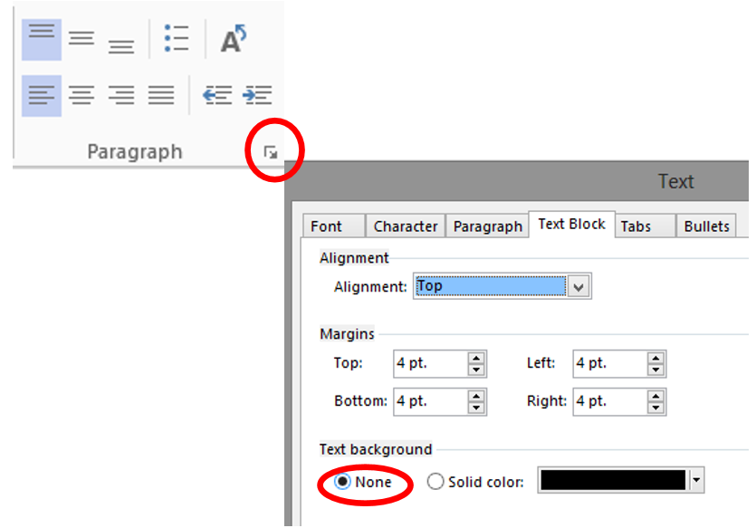

To use the Visio stencil file in Visio 2013:

1. Save the Visio stencil to your local machine.
2. Open a “blank” Visio document.
3. Open the stencil from the shapes pane as seen below.

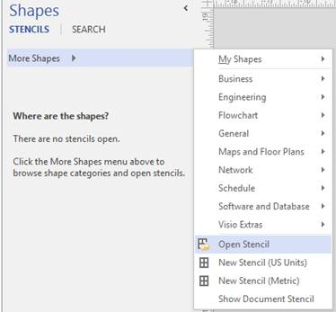

On some systems, you may also have to select “Show Document Stencil” at the bottom of the same menu.

These steps may be slightly different for other versions of Visio.

## PNG Export from Visio

A set of symbols in PNG form with a transparent background is also available. However, you can export your own PNGs using later versions of Visio. Select the symbol/picture that you want to export and then chose “Save As”. Use the values in this dialog as a guide for saving PNG symbols containing only a few solid colors. If you select entire diagrams, you can export those using higher resolutions in the “size” section. You may not want to use a transparency color in that case. If you use multiple colors, you may want to use the 256 color option.



If you use the supplied macro file (CSI_Art_Template_Save_*.vsdm), you can use a single keystroke to save individual symbols. Open the file for instructions.